***Software Engineering Project Report***

***Gather (A Family App)***

***Prepared by***

***Akshant Jain,***

***Ayna Jain,***

***Shaan Shekhar,***

***Tirth Patel***

**University of Illinois Chicago**

**Spring 2021**

**Table of Contents**

*1.* List of Figures 5

2. List of Tables 6

2. 6

I. Project Description 6

1 Project Overview 6

2 The Purpose of the Project 7

2a The User Business or Background of the Project Effort 7

2b Goals of the Project 7

2c Measurement 7

3 The Scope of the Work 8

3a The Current Situation 8

3b The Context of the Work 8

3c Work Partitioning 10

3d Competing Products 11

4 The Scope of the Product 11

4a Scenario Diagram(s) 11

4b Product Scenario List 11

4c Individual Product Scenarios 12

5 Stakeholders 13

5a The Client 13

5b The Customer 13

5c Hands-On Users of the Product 13

5d Maintenance Users and Service Technicians 13

5e Other Stakeholders 14

5f User Participation 14

5g Priorities Assigned to Users 14

6 Mandated Constraints 15

6a Solution Constraints 15

6b Implementation Environment of the Current System 15

6c Partner or Collaborative Applications 16

6d Off-the-Shelf Software 16

6e Anticipated Workplace Environment 16

6f Schedule Constraints 16

6g Budget Constraints 16

7 Naming Conventions and Definitions 17

7a Definitions of Key Terms 17

7b UML and Other Notation Used in This Document 17

7c Data Dictionary for Any Included Models 17

8 Relevant Facts and Assumptions 17

8a Facts 17

8b Assumptions 18

3. 19

4. II. Requirements 19

1 Product Use Cases 19

1a Use Case Diagrams 19

1b Product Use Case List 20

1c Individual Product Use Cases 21

2. 35

2 Functional Requirements 35

3 Data Requirements 36

4 Performance Requirements 38

4a Speed and Latency Requirements 38

4b Precision or Accuracy Requirements 38

4c Capacity Requirements 39

5 Dependability Requirements 40

5a Reliability Requirements 40

5b Availability Requirements 40

5c Robustness or Fault-Tolerance Requirements 41

5d Safety-Critical Requirements 41

6 Maintainability and Supportability Requirements 42

6a Maintenance Requirements 42

6b Supportability Requirements 42

6c Adaptability Requirements 43

6d Scalability or Extensibility Requirements 43

6e Longevity Requirements 43

7 Security Requirements 44

7a Access Requirements 44

7b Integrity Requirements 44

7c Privacy Requirements 45

7d Audit Requirements 46

7e Immunity Requirements 46

8 Usability and Humanity Requirements 46

8a Ease of Use Requirements 46

8b Personalization and Internationalization Requirements 48

8c Learning Requirements 49

8d Understandability and Politeness Requirements 49

8e Accessibility Requirements 50

8f User Documentation Requirements 50

8g Training Requirements 51

9 Look and Feel Requirements 51

9a Appearance Requirements 51

9b Style Requirements 52

10 Operational and Environmental Requirements 52

10a Expected Physical Environment 52

10b Requirements for Interfacing with Adjacent Systems 53

10c Productization Requirements 53

10d Release Requirements 54

11 Cultural and Political Requirements 54

11a Cultural Requirements 54

11b Political Requirements 55

12 Legal Requirements 56

12a Compliance Requirements 56

12b Standards Requirements 56

13 Requirements Acceptance Tests 57

13a Acceptance Test Descriptions 57

3. Description: Situations for account reset/recovery 60

*5.* Index 61

### List of Figures

Context of the Application 37

Figure 3 - Sample Use Case Diagram from Robertson and Robertson 37

### List of Tables

*If a document contains a large number of tables, then it is appropriate to include a list of tables at the beginning of the document, following the table of contents. Each table should include a title, and be numbered in a consistent logical fashion. The following list of tables was automatically generated from table captions ( see below), and can be automatically updated by right-clicking on the table below and selecting “Update Field”. This feature is located in the “Captions” section of the “References” tab in MS Word.* ***Note: Remove this instructional paragraph.***

*Table 2 - Requirements - Acceptance Tests Correspondence* 75

# 

# Project Description

## Project Overview

The product is a collaboration application which can be customized for each community/ group. It will help people to connect with each other even when they are miles apart. The users of this application can be in various groups such as family groups, office groups and friend circles. Career oriented children can use this application to get inspired for cooking homemade recipes during occasions. Also, this application will provide a way to connect with each other in an affectionate way by providing an inbuilt shopping platform to send gifts/essentials to your loved ones on occasions such as birthdays, anniversaries or festivals.

By means of family collaboration, this application will enable users to have virtual get-togethers such as virtual dinner and tea-parties, collaborative games and virtual shopping/ meetings hours for the group. This application will also keep track of all the important dates for all the members of the group providing a better foundation for the relationships.

## The Purpose of the Project

### The User Business or Background of the Project Effort

Staying in touch with family and friends is hard in this fast pacing world where people often forget to connect with their family members. Staying connected to one’s family is important and helps keep one motivated in times of distress. Current applications such as Whatsapp, messenger and zoom only provide basic texting and video calling. They can be replaced with a better tool. Gather provides a single platform for families to unite with one another. Gather will combine features that these applications provide with more modern features such as integrating calendar to remind people of birthdays, anniversaries and other important occasions of their loved ones, organize virtual get-togethers and play multiplayer games . The application also has an integration of online shopping platforms to send gifts/essentials to their family members on just a single click. Gather will help people connect with their loved ones which will provide better and stronger relationships.

### Goals of the Project

We want to help people connect with their families in this rapidly growing world where family members live and work around the world by providing them with a single platform to connect with their loved ones and establish and maintain better relationships.

### Measurement

The first step to measure the success of the product will be to track the number of app downloads. We would check the number of new users a particular user brings to the application. After that we would track the number of times the application is used in a week. This will allow us to know whether the users are liking the app or not and how fast the app is growing. Customer satisfaction surveys will be taken into account to measure the success of the application.

## The Scope of the Work

The goal of the work that will be addressed in this product is to provide people with ways to build relationships online and having the same interactions and exposures which they experience during in-person communication and meet-ups.

### The Current Situation

There are applications in the market that provide the mentioned services separately. Also, the already existing applications make it hard to keep track of everything within a community. Therefore, this application will provide means of communication in a systemized way. There will no longer be manual data charts and calendars in use as this product will manage all the user birthdays from the very moment they create their accounts. Although there will always be a room to add more important dates and virtual meetings or get-together reminders. Unlike other products in the market, this application will make it easier for people to know their family member choices in order to value their communication more effectively.

### The Context of the Work

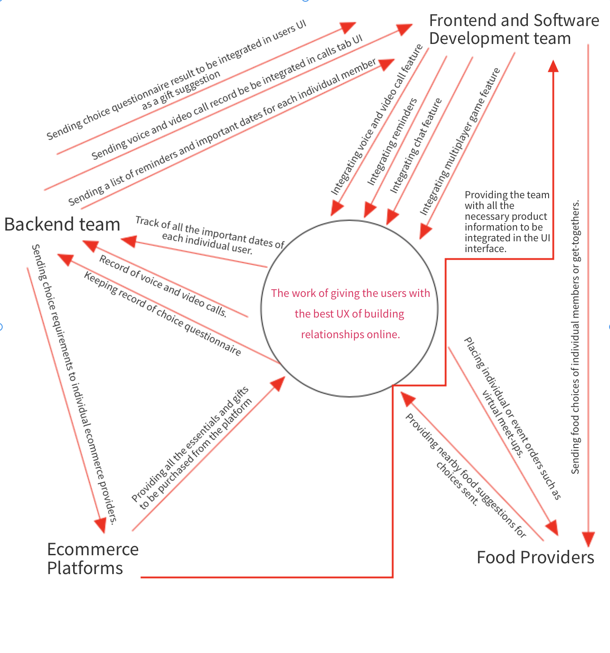

### Work Partitioning

|  |  |  |
| --- | --- | --- |
| Event name | Input and Output | Summary |
| Database management team keeps track of all the choices made in a questionnaire. | Individual users giving answers to choice questions in the questionnaire. | Record the choices made by each person in a group in order to use it to give gift suggestions to other members in the group. |
| Development team linking the choice questionnaire to the UI interface of individual users of the group. | Linking the UI Interface to the products from a particular ecommerce provider. | Determining the choice questionnaire and linking it in the best possible way to enhance gift sales on the ecommerce platform. |
| Development team keeps track of all the suggestion | Number of users giving similar kinds of suggestions. | Record the number of users having difficulty with the same problem and analyze their suggestions. |
| Development teams analyzing user suggestions to resolve the difficulty by integrating the feature in the product | Integrating analyzed suggestions. | Record the user suggestions, analyze them and integrate them in the feature. |
| Database management team keeping track of all the important dates. | tracking the important dates (in).  Sending reminders to different users according to their personalized reminder chart.(out) | Determining all the important dates whether it be pr-recorder or manual ones. Recording all the get-togethers and other events. Sending reminders to all the participants of the group. |
| Development team integrating all the required ecommerce providers. | Analyzing the needs of the users(in).  Updating the product by collaborating with the popular ecommerce providers.(out) | Determining the needs of the users. Collaborating with Amazon, Uber, doordash, etc., to provide the best user experience on building relationships online. |

### Competing Products

WhatsApp and zoom are some of the existing competing products to some extent. They provide a feature to create groups which can be used by families but they don't have a feature to remind users birthdays of their friends/family members, schedule virtual get-togethers, shop,play multiplayer games and send gifts. Gather is a single platform for families to keep in tune with each other. It is one platform that allows families living around the world to connect in a seamless manner.

## The Scope of the Product

Allow users to get connected with their family members with hassle and all in one platform.

### Scenario Diagram(s)

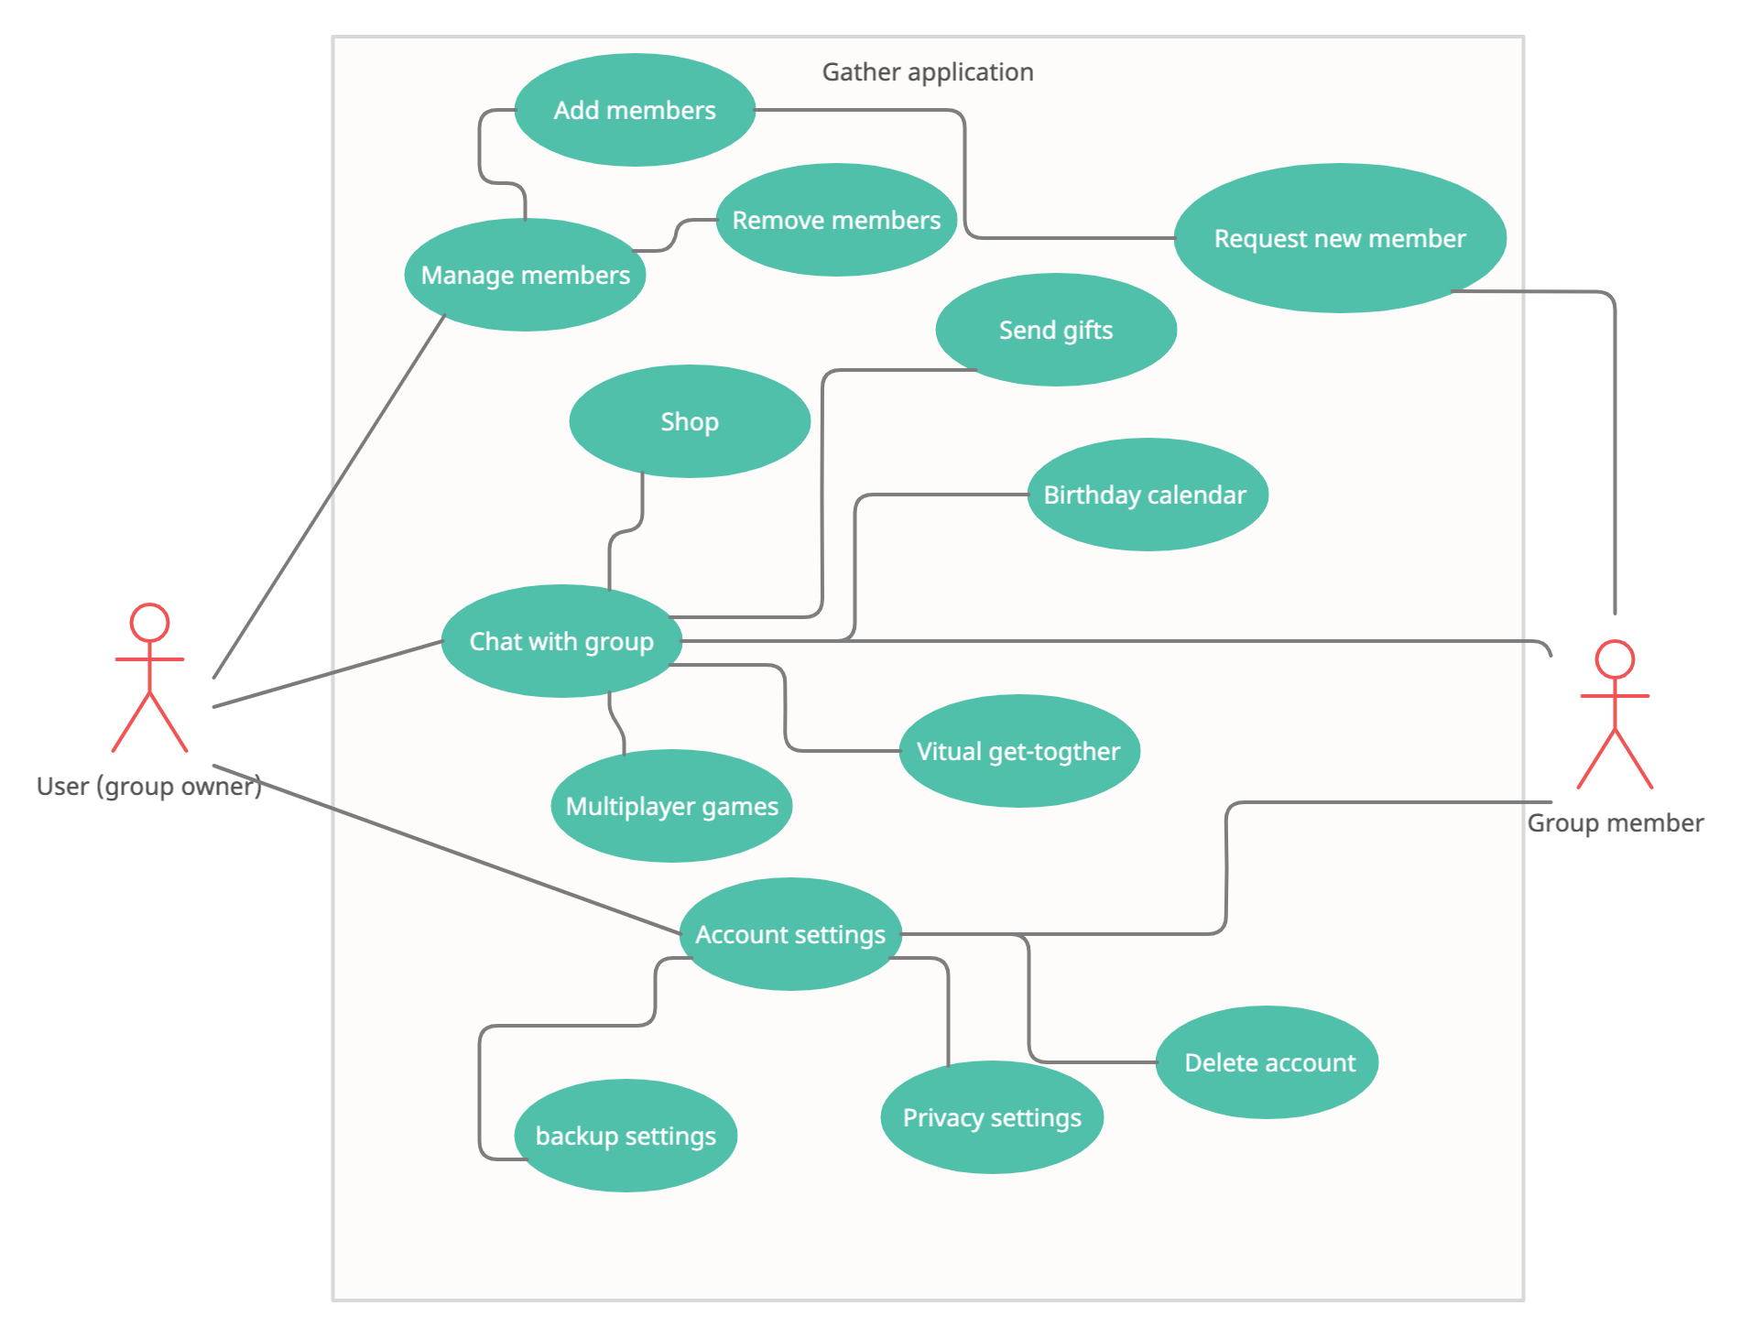

### Product Scenario List

1. Login validation for new and already existing users.
2. Allowing only the authorized users to join a particular group.
3. Tutorial on how to use the product in the form of a short interactive video.
4. Maintaining chats for each individual group.
5. Keeping track of all the voice and video calls made.
6. Keeping track of all the suggestions from the users and integrating them on the product on a timely basis.
7. Sending reminders to the group members for any upcoming events such as festivals, birthdays, or get-togethers.
8. Sending users with shopping suggestions regarding occasions.
9. Sending users with gift suggestions from the choices made by individual users.
10. Updating the product with all the necessary ecommerce platforms such as Amazon , Uber eats, Doordash, in order to make the experience more user friendly.

### Individual Product Scenarios

1. Login validation for new and already existing users:

* Username and password of all the existing users must be validated and all the new users must be prompted to create a new account.

1. Allowing only the authorized users to join a particular group:

* After creating a new account, users can join a group only through invite registration links or on request.

1. Tutorial on how to use the product in the form of a short interactive video:

* After creating a new account, the user should be prompted to watch a short video clip on how to use the product in an interactive way. The end result of this scenario would be any user creating a new group or joining a new group with the registration invite or making a request to join a particular group within 5 minutes after watching the video.

1. Maintaining chats for each individual group:

* All the users should have access to all the individual or group chats at any time of the day. By means, all the chats should be backed up in a cloud platform.

1. Keeping track of all the voice and video calls made:

* All the users should have access to their voice and video call history for upto to 50 calls. Moreover, the user should have an option to add a user to their contacts if the information is not saved on their device.

1. Keeping track of all the suggestions from the users and integrating them on the product on a timely basis:

* There should be a timely suggestion questionnaire for the users which will help the product to be updated with the integrated suggestions.

1. Sending reminders to the group members:

* Tracking all the important dates such as birthdays and anniversaries and sending reminders to them. Also, tracking any get-together dates and sending reminders to all the participants of that event.

1. Sending users with shopping suggestions regarding occasions:

* Sending users with timely shopping suggestions or shopping get-together ideas around the time of existing or manually updated occasions.

1. Sending users with gift suggestions from the choices made by individual users:

* Sending choice suggestions to all the users on their birthdays and anniversaries. Sending gift suggestions to the rest of the users on choices made by that “special” person. This will facilitate better relationships.

1. Updating the product with all the necessary ecommerce platforms:

* Integrating all the necessary ecommerce platforms such as Amazon, Uber, Doordash in order for the users to have a smooth virtual meet-ups which can be in any form including virtual family dinners with the same menu delivered from Uber to all the participants.

## Stakeholders

### The Client

The client of the product is the development team of the application, i.e. a non external client. In case an external client is interested in the development of the product, it becomes a part of the development team, or, a client.

### The Customer

External customers are various restaurant businesses and/or delivery companies that would purchase specific segments of the application to display promotions of their products. Additionally app users would be given an option to pay a subscription fee to remove sponsorship advertisements.

Moreover, adding new features in the application based on specific requests of customers would come at a set fee.

### Hands-On Users of the Product

Since a free version of the application can be downloaded directly from the App Store, Google Play Store, or Microsoft Store depending on the operating system of the user, the application expects users of all types and ages.

Groups of any possible type primarily including family groups, study groups, office workers’ groups, friend circles, or any casual groups, including people of all age groups are expected to exist on the application.

Paid promotions by a variety of different companies will benefit the users as they would be shown appropriate advertisements according to their group types.

The hands on users will also be able to avail special discounts when they participate in a referral program, which would, after all, increase activity of users in the application.

### Maintenance Users and Service Technicians

Although the development team is responsible for extensively testing and timely updating the application, the application itself supports a bug reporting system which can be utilized to notify the development team about any bugs in the application, and also allow the hands on users to give suggestions for further improvements in the application.

### Other Stakeholders

The other stakeholders include:

1. Sponsors: the sponsors can control content on specific portions of the application, which is a determining factor in the success of the sponsor and the other stakeholders.
2. Marketing and Distribution Team: the team is responsible for promoting the application on multiple platforms including online and offline platforms.
3. Ambassadors: affiliated social media influencers will promote the application on various social media websites.
4. Legal experts: responsible for looking into legal issues related to the unauthorized/illegal use of application for distributing copyrighted materials, any external agency modifying the application, etc.

### User Participation

The participation of the user is a big part of the development process of the application. After the first initial release of the application, the development team will rely heavily on the bug reporting system of the application to resolve issues and make the experience better for the hands on users. Moreover, adding new features to the application and handling specific requests of the sponsors is highly dependent on user activity on the application.

### Priorities Assigned to Users

Although all the users will have availability to the same features of the application, there will be some priorities that will be available to only a specific group of users.

Firstly, the premium users of the application (i.e. users with a premium subscription), will see no ads. In contrast, the free users will see ads, although ads will not cover any content in the application.

Secondly, sponsorship is based on the best-offer method i.e. the one who gives a higher price for the sponsorship will get the priority.

Lastly, the users who have been active members will receive special offers and discounts on products that will not be available for every user. Similar types of offers will pop up every now and then for specific users that will be account specific and cannot be utilized by other users.

## Mandated Constraints

### Solution Constraints

The application must be able to download at 3G connection on a hand held device and should not take more than 100MB of space. The application should be supported on android 7 and above and on iOS version 7 and above. The above versions are chosen by taking into consideration that most users have these versions already on their hand held devices and they do not have to update their device to install the application. The application should also be supported on web browsers such as firefox, chrome, brave, safari and edge.

### Implementation Environment of the Current System

The application supports Android, iOS, mac OS, and Windows operating systems. At a minimum, the minimal requirements for the application to function properly i.e. support all features are as follows:

Android:

* Android Nougat (7) and above.
* Minimum of 100mb of available storage
* Supports Google Play Services
* Has dedicated sensors for audio input (microphone), Camera and GPS location tracking

iOS/macOS:

* iOS 10.0 and above/ macOS High Sierra and above.
* Minimum of 100mb of available storage
* Supports Apple Services
* Has dedicated sensors for audio input (microphone), Camera and GPS location tracking
* Non jailbroken device

Web Browsers (all platforms like laptops, ipads, computers etc.):

* Google Chrome, and Safari
* Minimum of 150mb of available storage
* Has dedicated sensors for audio input (microphone), Camera and GPS location tracking

In addition to this, some features of the application require spending real money. The quality of experience of the application mostly depends on the hardware and operating system.

### Partner or Collaborative Applications

The application will have integration for popular services such as UberEats, Grubhub, Doordash, etc. such that food orders for virtual get-togethers can be placed directly through the application.

For example: Suppose there is a group of 8 members who will be attending a virtual get together. As a central theme for the get together, suppose they want to order pizza from Domino’s pizza for everyone. One person can order pizza for all the 8 members and the money can get split between all 8 members, if required. Moreover, since all the members are staying at 8 different places, the app will be integrated in such a way that the nearest Domino’s pizza shop will get the order for the nearest member.

Integration with other apps like Amazon, Uber, Lyft and FedEx will be implemented for delivery of packages which may include gifts, essential items, etc.

### Off-the-Shelf Software

Since the product itself is a software package, the “Off-the-shelf Software” is more like instruction tutorials when some new user installs the software for the first time. Moreover a section in the application will contain short tutorials and instructions that will allow the user to get to know and utilize the application in the best way possible.

### Anticipated Workplace Environment

The application is anticipated to be taken into use in any working environment. There is no specific workplace environment requirement, until and unless the hardware and software requirements are made, the application can be utilized anywhere. As most of the features of the application will work online, an Internet connection is required to use the application. For first time users, email verification and mobile verification (although not always) are required.

### Schedule Constraints

No such specific schedule constraints apply to the product.

### Budget Constraints

The budget of this project should be around $500,000 and should take about 3 months to build where the development team will include 2 UI designers, and 3 developers for integrating and testing, 1 legal advisor, and 2 marketing and distribution team members. Moreover, most of the money will be spent on getting external companies (Uber, FedEx, etc.) onboard with the project.

The funds for the project could be gathered through different companies like Doordash, grubhub in exchange of promoting their platforms on the app. Moreover e-commerce companies like Amazon, Best buy could also be fund raisers for the project to promote their platforms and to promote more delivery options rather than pick up options.

## Naming Conventions and Definitions

### Definitions of Key Terms

Shopping: A place where the user will be able to make a shopping list for someone instead of himself.

Suggestions: Menu item where the user will be able to see the suggestions given by their loved ones.

Gifts: A Menu item where people can see the gifts sent by their loved ones through e-commerce and give them an option to thank them for the gratitude.

Food Menu: A place where the menu for the gatherings and parties could be shared with the invitees and then provide them links with the places where they can order specific dishes from.

Deliver: An option provided for a pick up and deliver service where people could request pick up from a place and then deliver to their loved ones at another place either through an external delivery system or through someone who is planning to travel to the same destination.

### UML and Other Notation Used in This Document

The conventions for symbols, diagrams and notations to be used in the document refer to UML standards in UML Distilled, 3rd Edition by Martin Fowler.

### Data Dictionary for Any Included Models

User: Personal information, payment information, location, visibility

Group: details, Users, managers, calendar, sub-groups, planner

Party/Gathering: Organisers, invitees, Menu, and location

Family: Members, shared information, location

Images (formats): jpeg, jpg, png, tif, and raw images

Videos (formats): mp4, mpeg-4, mov, mkv, and WebM

Documents (formats): docs, pdf, pptx, and xls

## Relevant Facts and Assumptions

### Facts

The product will be beneficial for the users who depend on their families for selecting the products after they move away from their home and are inexperienced with managing home on their own. The product will attract those families who like to send suggestions to their loved ones and rather than depending on other platforms, they can share and suggest new supplies, food and other essentials on the same place instead of using multiple platforms to get rid of those multiple links in the chat area.

### Assumptions

* The user has basic knowledge of using smartphones and other devices on which they want to use the app.
* The user has a stable internet connection to use the app features.
* The user should be comfortable in making online payments and sharing personal and payment details over the internet.
* The user has knowledge about pick up and delivery systems like amazon, food services like doordash and messaging services like whatsapp which are already present in the public domain for public use.

# 

# II. Requirements

## Product Use Cases

### Use Case Diagrams

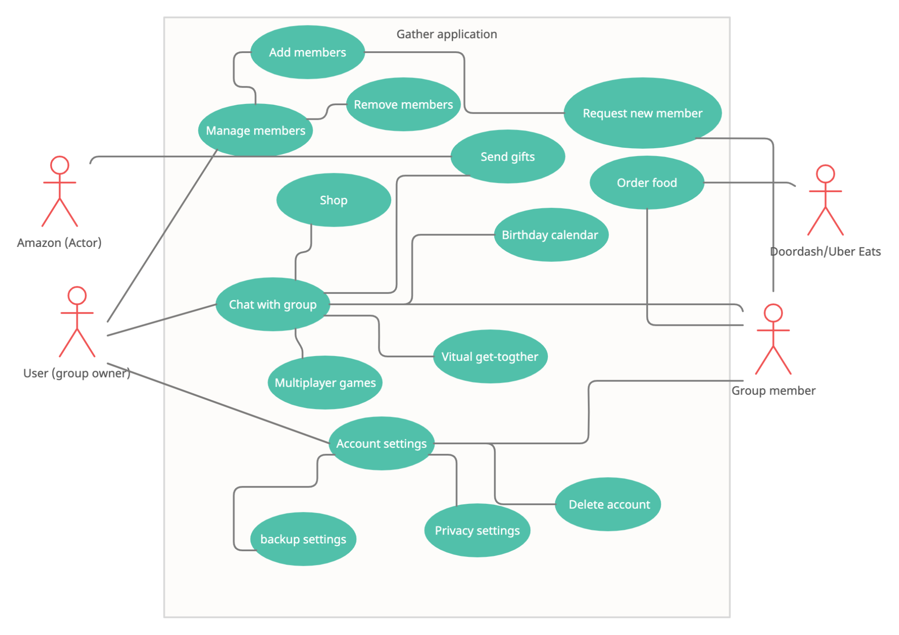

### 

### Product Use Case List

1. Add Members
2. Manage Members
3. Remove Member
4. Request New Member
5. Group Chat
6. Shop
7. Games
8. Calendar
9. Gifts
10. Get-together
11. Order Food
12. Account Settings
13. Backup Settings
14. Privacy Settings
15. Delete Account

### 

### Individual Product Use Cases

|  |
| --- |
| Use case ID: 101 Name: Add Member  pre-conditions: A group is required to add a user into, the new user should have an account and the initiating user should be the admin of the group  post-conditions: N/A  Initiated by: Admin (group Owner)  Triggering Event: Click on the add member button in the group submenu  Additional Actors: New User |
| Sequence of Events:   1. Admin clicks on the options button from the group chat window 2. The submenu pop-ups with different options in the submenu 3. Admin clicks on the add button. 4. A new dialog box opens and asks for the ID of the new user. 5. Admin enters the ID of the new user and clicks ‘ADD’ 6. System sends an invitation to the invited user if there exists such ID or else shows error. 7. User selects either ‘Accept’ or ‘Decline’. 8. The system sends the response to the Admin and modifies the group accordingly. |
| Alternatives: N/A  Exceptions: N/A |

|  |
| --- |
| Use case ID: 102 Name: Manage Members  pre-conditions: The user should be the admin of the group.  post-conditions: N/A  Initiated by: Admin (group owner)  Triggering Event: Click on the manage member button in the group submenu  Additional Actors: N/A |
| Sequence of Events:   1. Admin clicks on the options button from the group chat window 2. The submenu pop-ups with different options in the submenu 3. Admin clicks on the Manage button. 4. A new dialog box opens with the list of all the group members.. 5. Admin reviews/changes the roles of members, name, and other information and clicks the back button. 6. The system modifies the group information accordingly. |
| Alternatives: N/A  Exceptions: N/A |

|  |
| --- |
| Use case ID: 103 Name: Remove Member  pre-conditions: The actor should be the admin of the group.  post-conditions: N/A  Initiated by: Admin (group owner)  Triggering Event: Click on the manage member button in the group submenu  Additional Actors: N/A |
| Sequence of Events:   1. Admin clicks on the user profile whom he wants to remove from the group. 2. A new windows open with the information of the user 3. Admin scroll down the window and click on the “remove user from group” button. 4. System asks for confirmation from the Admin. 5. Admin Verifies its response. 6. System modifies the group according to the response. |
| Alternatives: N/A  Exceptions: N/A |

|  |
| --- |
| Use case ID: 104 Name: Request New Member  pre-conditions: The user should be a member of the group and have the ID of the member he wants to add to the group.  post-conditions: N/A  Initiated by: User (group owner)  Triggering Event: Click on the manage member button in the group submenu  Additional Actors: Admin |
| Sequence of Events:   1. User clicks on the options button from the group chat window 2. The submenu pop-ups with different options in the submenu. 3. The user clicks on the Request Member option 4. A new pop-up dialog box appears asking for the ID of the new member. 5. User inputs the ID and clicks on the request button. 6. Systems sends the request to the Admin. 7. Admin either ‘Accept’ or ‘Decline’ the request. 8. The system performs the Add or Remove action accordingly. |
| Alternatives: N/A  Exceptions: N/A |

|  |
| --- |
| Use case ID: 105 Name: Group Chat  pre-conditions: Should be a member of the group.  post-conditions: N/A  Initiated by: Group Member  Triggering Event: Message sent in the group  Additional Actors: Group Member |
| Sequence of Events:   1. The user clicks on the group he wants to chat in 2. A new window opens with the chat history, chat box, and other elements. 3. The user types in the message in the chat input box and then clicks on the send button. 4. Systems adds the message to the chat history and notifies other group members. 5. Other group members open and reply to the message accordingly. 6. System adds the message again and the loop is continued. |
| Alternatives: N/A  Exceptions: N/A |

|  |
| --- |
| Use case ID: 106 Name: Shop  pre-conditions: Should have the merchant account  post-conditions: N/A  Initiated by: User (group member)  Triggering Event: Click on the shop button  Additional Actors: shopping merchants like Amazon. |
| Sequence of Events:   1. The user clicks on the Shop button inside the group chat window. 2. A pop-up box appears with the available shopping merchants. 3. User selects the merchant and press continues. 4. A new window opens with the merchant interface. 5. The user selects the items he wants to shop and adds them to the cart and then clicks on the export cart. 6. The system parses the command and pop-ups a dialog box asking for the action (share with group, user, or save in drafts) |
| Alternatives: N/A  Exceptions: N/A |

|  |
| --- |
| Use case ID: 107 Name: Games  pre-conditions: Member of the group  post-conditions: N/A  Initiated by: group member  Triggering Event: Click on the game button  Additional Actors: Group Members |
| Sequence of Events:   1. The user clicks on the play games option from the group chat window. 2. A pop up window opens with the list of games. 3. User selects the game he wants to play. 4. System initiates the game and asks for the user to wait and send an invitation to every member of the group to play the game and waits for a certain time before closing the game and declining the user request to play the game. 5. Another user accepts the game request. 6. The system starts the game. |
| Alternatives: N/A  Exceptions: N/A |

|  |
| --- |
| Use case ID: 108 Name: Calendar  pre-conditions: Member of the group  post-conditions: N/A  Initiated by: User  Triggering Event: Click on the calendar button  Additional Actors: N/A |
| Sequence of Events:   1. The user clicks on the calendar from the group chat window. 2. A new window opens with the upcoming events in different views (Day, Week, Month, or Year) according to the selection. 3. The user clicks on a certain event and reviews the information. |
| Alternatives: N/A  Exceptions: N/A |

|  |
| --- |
| Use case ID: 109 Name: Gifts  pre-conditions: Member of the group  post-conditions: Confirmation from the receiver  Initiated by: User  Triggering Event: Click on the send gift button  Additional Actors: Shopping Merchants like Amazon |
| Sequence of Events:   1. User clicks on the send gift option from the options menu. 2. System opens up the shopping platforms and lets the user navigate through the interface and select the gifts and export the gift list back to the application. 3. The user selects the user he wants to send the gifts to. 4. The system asks for the delivery details and initiates the delivery through the selected merchant. |
| Alternatives: N/A  Exceptions: N/A |

|  |
| --- |
| Use case ID: 110 Name: Get-together  pre-conditions: Admin of the group  post-conditions: Send a invite link to all the members  Initiated by: Group Admin  Triggering Event: Click on plan event in the chat window  Additional Actors: Group Members |
| Sequence of Events:   1. The Admin creates a new event using the calendar services along with the details. 2. System sends notifications to the members before the start of the event. 3. Members join the meeting through the details of the meetings. |
| Alternatives: N/A  Exceptions: N/A |

|  |
| --- |
| Use case ID: 111 Name: Order Food  pre-conditions: Member of the application and have an active account with the food merchant  post-conditions: Confirmation from the receiver  Initiated by: User  Triggering Event: Click on order food  Additional Actors: Food Merchant. |
| Sequence of Events:   1. During the get-together, the user clicks on order food. 2. Systems shows different options according to the availability and setting made by the meeting organiser and redirects to the food merchant 3. User selects the items he wants to order and then clicks on the ‘Order’ and makes payments. 4. The system initiates the order and sends it to the merchant and the food merchant processes the order. |
| Alternatives: N/A  Exceptions: N/A |

|  |
| --- |
| Use case ID: 112 Name: Account Settings  pre-conditions: Have an account  post-conditions: N/A  Initiated by: User  Triggering Event: Click on account button from the main screen  Additional Actors: N/A |
| Sequence of Events:   1. The user clicks on the options button from the main window. 2. A submenu pop-up with different options. 3. User selects the Account option. 4. A new window opens with different sections. |
| Alternatives: N/A  Exceptions: N/A |

|  |
| --- |
| Use case ID: 113 Name: Backup Settings  pre-conditions: Have an account  post-conditions: N/A  Initiated by: User  Triggering Event: Click on backup button in the account settings  Additional Actors: N/A |
| Sequence of Events:   1. The user clicks on the options button from the main window. 2. A submenu pop-up with different options. 3. User selects the Account option. 4. A new window opens with different sections. 5. User selects the Backup option. 6. A new window pop-up with the current backup settings. 7. User reviews and makes changes accordingly and submits. 8. The system updates the personal backup settings accordingly |
| Alternatives: N/A  Exceptions: N/A |

|  |
| --- |
| Use case ID: 114 Name: Privacy Settings  pre-conditions: Have an account  post-conditions: N/A  Initiated by: User  Triggering Event: Click on privacy button from the account settings menu  Additional Actors: N/A |
| Sequence of Events:   1. The user clicks on the options button from the main window. 2. A submenu pop-up with different options. 3. User selects the Account option. 4. A new window opens with different sections. 5. User selects Privacy option. 6. A new window pop-up with the current privacy settings. 7. User reviews and makes changes accordingly and submits. 8. The system updates the personal privacy settings accordingly. |
| Alternatives: N/A  Exceptions: N/A |

|  |
| --- |
| Use case ID: 115 Name: Delete Account  pre-conditions: Have an account  post-conditions: Confirmation from the user.  Initiated by: User  Triggering Event: Click on delete account button from the account settings  Additional Actors: N/A |
| Sequence of Events:   1. The user clicks on the options button from the main window. 2. A submenu pop-up with different options. 3. User selects the Account option. 4. A new window opens with different sections. 5. User selects Delete my account option. 6. System asks for confirmation through SMS/Email and initiates the request according to the response. |
| Alternatives: N/A  Exceptions: N/A |

## 

## Functional Requirements

**ID 1-** Tutorial

**Description:** Provides new users a tour of the application.

**Rationale:** For providing new users an easy way to move forward and understand the product easily.

**Fit Criterion:** Must be a new user.

**Acceptance Tests:** Tutorial.

**ID 2 -** Import and parse data from multiple merchants

**Description:** Takes an input from the third party merchants and parses.

**Rationale:** To let users transfer data from the merchants interface and then share it with other members of the group.

**Fit Criterion:** the merchant should be a valid partner of the product.

**Acceptance Tests:** UberEats/Doordash Compatibility.

**ID 3 -** Backup

**Description:** Back up the user settings, group settings and chat history to the server.

**Rationale:** To let user backup their data to allow them to restore it anytime

**Fit Criterion:** The user should have turned on the backup.

**Acceptance Tests:** Save Data

**ID 4 -** 10 Members per Group

**Description:** A maximum of 10 people could be added to the group.

**Rationale:** To avoid application crash and let users chat and use features seamlessly.

**Fit Criterion:** A group should be created with users.

**Acceptance Tests:** Capacity of users.

**ID 5 -** Images/Audio/Video Files

**Description:** Users are able to share audio and video files with other users.

**Rationale:** To let users share images, audio and video files for more effective communication.

**Fit Criterion:** Users should have these kinds of files and applications to open them.

**Acceptance Tests:** Images**/**Audio/Video files.

## Data Requirements

Gather is a completely online platform and there are no data storage requirements for the application. Apart from the initial storage space requirements for installation of the application/software, the messages and media are stored in the server. Although, some features of the application may require space for functioning properly, for example, a user making a video call may require temporary cache memory to allow good quality video call.

Note: all the user data will be protected with some form encryption.

**ID 6 - Minimal Storage**

**Description:** Depending on the platform the application is running on, it will have a minimum storage requirement.

**Rationale:** For proper functioning of the application, a minimum storage space is required to store temporary files, application cache, and temporary media.

**Fit Criterion:** The application is supposed to require at least 100MB of installation space. Hence, a device is compatible if it has a minimum of 100MB empty storage.

**Acceptance Tests:** Minimal Requirement

**ID 7 - Temporary Server**

**Description:** Before sending the data to the main server, it will be stored in a temporary server.

**Rationale:** Any text or media will be stored in the temporary server as it will allow users to unsend a message, faster processing of media, low latency and high accuracy.

**Fit Criterion:** Any media file exceeding a specific size processed in the temporary server first before sending to the main server.

**Acceptance Tests:** Temporary Server

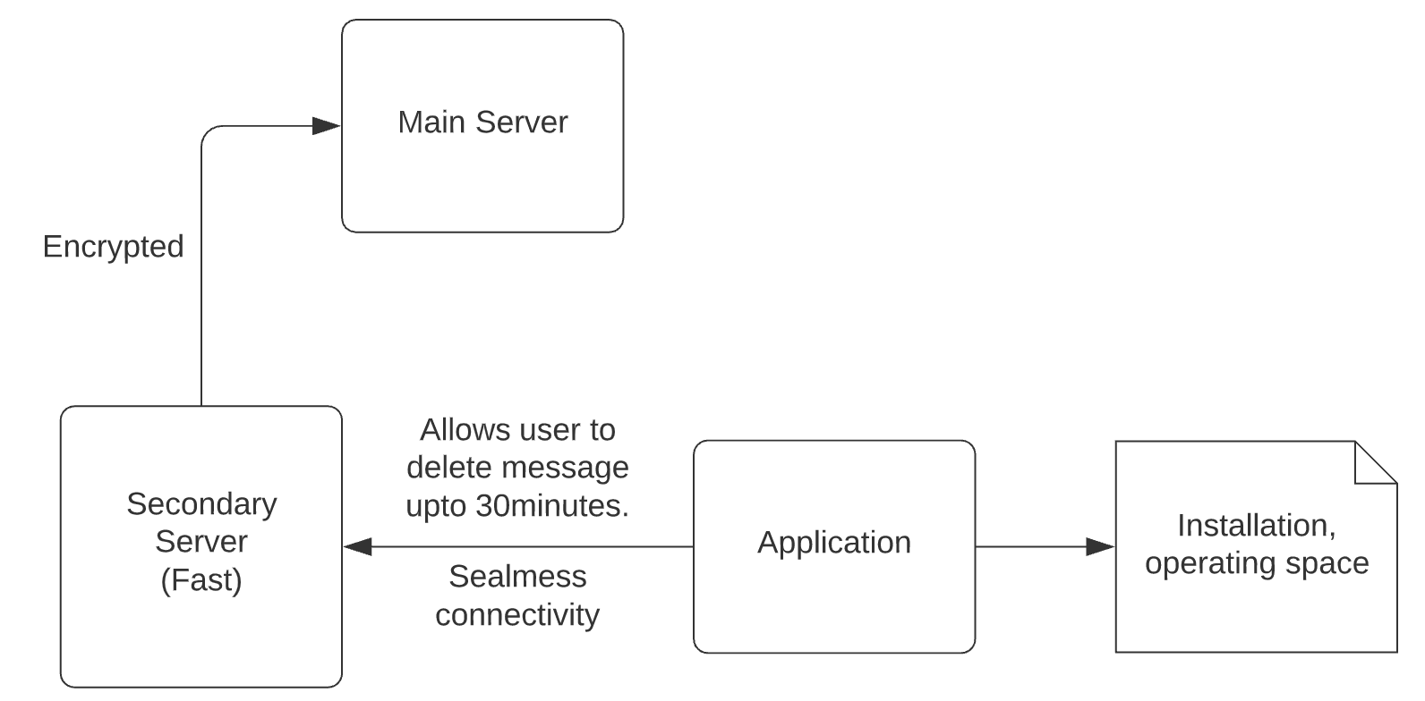

## Performance Requirements

### Speed and Latency Requirements

**ID 8 - Low Latency High Accuracy**

**Description:** The application should have low latency and high accuracy

**Rationale:** Users want the communication to be as fast and seamless as possible and to achieve that low latency maintaining high accuracy is important.

**Fit Criterion:** Any internet communication should average a latency of about 10ms and an average accuracy of 1ms.

**Acceptance Tests:** Low Latency High Accuracy

**ID 9 - Multiple shares**

**Description:** If a user wants to share a single video to multiple people, processing can be done only once and not for each share individually.

**Rationale:** Fast media sharing, reduced processing time.

**Fit Criterion:** All data must be processed on a temporary server, so if a user wants to send a media file to multiple users, the processing of the media takes place only once, and the whole process becomes faster.

**Acceptance Tests:** Multiple shares, Temporary Server

**ID 10 - Video Quality**

**Description:** The video quality should be set automatically.

**Rationale:** Hassle free video calling, better video calls at less internet speeds.

**Fit Criterion:** The quality of the video call is set automatically depending on the internet speed of the user. This ensures that the video call is smooth and the call does not keep on dropping frequently.

**Acceptance Tests:** Video Quality, Low Latency High Accuracy.

### Precision or Accuracy Requirements

**ID 11 - Privacy**

**Description:** Accurate tracking of the data is important for maintaining the privacy of the user.

**Rationale:** Inaccurate information tracking might cause privacy issues.

**Fit Criterion:** Inaccurate data storage might show data of one user to another user. Messages sent to one user can end up being received by another user.

**Acceptance Tests:** Privacy

**ID 12 - Payment Gateway**

**Description:** Bank information should be accurate, may require 2 step authentication.

**Rationale:** Use ofstolen bank information should be prevented at all costs. Using the same payment methods on multiple accounts and exploit app promotions should be avoided.

**Fit Criterion:** If the same payment method is being utilized to take benefit of any app promotions, the promotions should be removed from the account. If the same payment method is being utilized again and again (or over $50), 20-step verification should be used to verify the transaction.

**Acceptance Tests:** Payment Gateway, Privacy

**ID 13 - Backup and Recovery**

**Description:** Account backup and recovery should be carried over only on the main server.

**Rationale:** Daily/Weekly/Monthly account backup should be carried for account recovery (or transfers).

**Fit Criterion:** Complete and accurate backup of user data should be encrypted and stored in the mainserver which should be utilized during times when the user wants to switch device/account.

**Acceptance Tests:** Backup and Recovery.

### Capacity Requirements

The application is expected to have groups of about average of 25-50 people with support of about 1 million active users at any given instance. Which translates to about 20k-40k active groups being able to utilize all features of the application without any lag and minimum latency.

**ID 14 -** Minimum Server Capacity

**Description:** Minimum capacity of 1 million active users are supported.

**Rationale:** For the company’s profit, the application should support a large number of groups who can take benefit of all the features of the application without any lag.

**Fit Criterion:** About 20k-40k groups with an average of 25-50 people should be supported by the application.

**Acceptance Tests:** Minimum Server Capacity

**ID 15 -** Maximum Media Capacity

**Description:** Media capacity capped at a certain limit for each kind of media.

**Rationale:** Large media files will take up huge processing capacity and time, and might put lag in features.

**Fit Criterion:** Maximum capacity for any type of media share is capped at a 100MB.

**Acceptance Tests:** Maximum Media Capacity, Low Latency High Accuracy

## Dependability Requirements

### Reliability Requirements

**ID 16 -** Stability Rate

**Description:** Operate at a very high success rate.

**Rationale:** Users want hassle free and smooth experience of the application.

**Fit Criterion:** The application will not fail and shall operate with stability about 99.5% of the time and shall not crash due to errors in the functioning of the application.

**Acceptance Tests:** Stability Rate

**ID 17 -** App Crashes/Update

**Description:** No data loss in case of app crashes.

**Rationale:** Part of hassle free and smooth application.

**Fit Criterion:** No data shall be lost in case the application crashes or updates due to routine automatic backup in the main server.

**Acceptance Tests:** Stability Rate, App Crashes/Update

### Availability Requirements

**ID 18 -** Availability

**Description:** Available all year round 99.9% of the time.

**Rationale:** Part of hassle free and smooth application. Non seasonal product.

**Fit Criterion:** The application shall be available 99.9% of the time all year round. In case of maintenance, the application will not stop functioning (or affect functioning of a feature) as the cool down times of the servers will go in circles.

**Acceptance Tests:** Stability Rate, App Crashes/Update, Availability.

### Robustness or Fault-Tolerance Requirements

**ID 19 -** States

**Description:** Very less to no data loss in any state of the application.

**Rationale:** Part of hassle free and smooth application.

**Fit Criterion:** The state of the application shall be saved when the application is paused, or kept in the background, and shall be restored when the application is opened. In case the application is closed, all data must be saved and updated in the server, which shall be utilized when the application is reopened.

**Acceptance Tests:** Stability Rate, App Crashes/Update, Availability, States

**ID 20 -** Device Switching

**Description:** Works across all devices. No data loss in case of switching devices.

**Rationale:** Part of hassle free and smooth application.

**Fit Criterion:** In case the user wants to switch between devices, the application must load all things intact as in the previous device without any loss of data.

**Acceptance Tests:** Stability Rate, App Crashes/Update, Availability, Device Switching.

### Safety-Critical Requirements

**ID 21 -** Short Term

**Description:** Health and financial loss.

**Rationale:** Short term loss in health and probable financial crisis.

**Fit Criterion:** The application integrates with food ordering services which involves health and financial risks. (food allergies, poor quality food from the restaurant, spending too much on food, etc.)

**Acceptance Tests:** Short Term.

**ID 22 -** Long Term

**Description:** Health issues.

**Rationale:** Long term loss in health..

**Fit Criterion:** Indirect effect of excessively using the application on a screen that releases blue light is harmful for eyes in the long term

**Acceptance Tests:** Short Term. Long Term.

## Maintainability and Supportability Requirements

### Maintenance Requirements

**ID 23 - Name**

It is important for any Software Maintenance to document the plan and have the client read and understand it . For example, if any major product changes that are usually scheduled to be released after 6 months, then it is important for a client to agree to it rather than rushing on the next release. It is also important to look after your availability to the client without any restrictions in contacting.

* All bugs discovered at any time will be logged on the server and forwarded to the development team, who will work on fixing them until the next product release.
* For any changes that need to be referred to in the future, the documentation for the complete development and implementation process must be kept with all the source code backed up.
* The product should have scheduled timely updates to enhance the loading time and the efficiency of the release.
* The training process that covers all the design, implementation process, ethics, consent and testing methodologies must be made compulsory for all the new members joining the team.

### Supportability Requirements

* A feedback form should be implemented for the user to provide feedback on any bug fixes for the product.
* The website should be compatible with all the leading and modern web browsers and devices such as Internet Explorer, Chrome, Safari, Firefox, Microsoft Edge.
* There should be a help page with all the documentation to connect and use the product where the users can search for related questions for any issues that they might face.
* A timed service desk should be set up for the staff to answer questions for the users for any technical issues that they might be facing while operating the product.

### Adaptability Requirements

**ID 25 - Name**

For the final software system to be adaptable, the software architecture and implementation must be adaptable as well.

* The Software Adaptability requirements should be considered during the development process in order for it to be completely implemented in the final product.
* It is also important to test the software at various stages of development. For example, if the software is designed and implemented for all size devices such as mobile, tablets and computers, then it is important to test it on different devices mentioned during the implementation process in order to fix any bugs with the product with different platforms and different orientation.
* It is important to consider the market of the product. For example, A software is to be released in a certain region then it is important to test the adaptability of the product in that region’s most popularly used platforms and devices.

### Scalability or Extensibility Requirements

**ID 26 - Capacity of users**

**Description:** The product should be able to handle 1 million people at a time. Though there is a possibility to reach 5 million in the first 3 years of the release.

**Rationale:** The product is targeted to family groups mostly. Therefore, there will be groups which will have 50 members at a time. So, the product will be able to accommodate as many family groups as possible reaching its maximum capacity.

**Fit Criterion:** If the capacity exceeds the existing one then the product should not hang for existing users and the development process should be pre-planned to increase the capacity in one night.

**Acceptance Tests:** User Capacity

### Longevity Requirements

**ID 27 - Budget fixed for 5 years**

**Description:** The product should be able to operate on the fixed budget or decided budget for at least 5 years.

**Rationale:** There are chances that product requires extra space for adding new users according to the user Capacity requirements within 5 years of releasing the project.

**Fit Criterion:** Software maintenance for the extra cloud storage budget must be pre-planned and included in the extra-budgets section in order to avoid the product down-time in case of customers exceeding the capacity.

**Acceptance Tests:** Budget fixed

## Security Requirements

### Access Requirements

**ID 28 - Admin Access**

**Description:** Additional access to group admins.

**Rationale:** Some group related settings are better to be in the hands of the admins of the groups.

**Fit Criterion:** Add/remove users, theme related group settings, add/kick someone out of group meetings.

**Acceptance Tests:** Admin Access

**ID 29 - Basic user access**

**Description:** user access options

**Rationale:** simple personalization access, privacy settings, etc.

**Fit Criterion:** personalization access to change personal theme of the application. Additionally, a user can change their privacy settings according to their will. Enable/disable personalized ads, etc.

**Acceptance Tests:** User Access

### Integrity Requirements

**ID 30 - Account safety**

**Description:** Situations for account reset/recovery

**Rationale:** Account safety becomes an important factor when user’s personal data is contained in the account. So, different account safety procedures are available for the users.

**Fit Criterion:** Since the application is a group based application, if the account of a single group member gets compromised, the other members have the option to report the matter. The same can be done by the account owner.

In case of deleting an account, the user is given the option to keep all their data which is exported in a zip file and given to the user. This can be used to recover all the data in case making a new account.

In case of switching an account to a different email/phone, that can be done directly in the settings menu.

**Acceptance Tests:** Account Safety

### Privacy Requirements

**ID 31 - Ad tracking**

**Description:** enable/disable user activity tracking to hide/show personalized ads.

**Rationale:** showing personalized ads can be useful for the user in certain situations, it helps out the app developers to keep the service running.

**Fit Criterion:** Ad tracking will allow the app to show personalized ads to the user. Although the app will not sell/leak the data to foreign companies, it will utilize it to suggest ads which are relevant to the user. The user will have the option to disable ad tracking, and subscribe users can completely turn off this feature.

**Acceptance Tests:** Ad tracking.

**ID 32 - Encryption**

**Description:** Ene-to-end encryption protocol for communication.

**Rationale:** privacy protection of the user data.

**Fit Criterion:** The application will utilize the end-to-end encryption protocol for communication. That way it will ensure complete privacy of the user. Moreover, the data stored in the main server will be encrypted in such a way that if any possible data breach occurs, there will be no chance the data will be decrypted.

**Acceptance Tests:** Encryption

### Audit Requirements

**ID 33 - Organizational Aspects**

**Description:** Developer unrelated, the adopting company has the power to decide the audit rules.

**Rationale:** The adopting organization shall be given the power to decide what shall be recorded in the application.

**Fit Criterion:** Legal aspects, what information should be taken of the user (data), what kind of advertisements, etc. are in the hands of the adopting company and under their rules. For example if a clothing corporation takes over, it's their decision to decide if the ads will be clothing related, etc.

**Acceptance Tests:** Organization Rules

### Immunity Requirements

**ID 34 - Application Immunity**

**Description:** Resilient to viruses, piracy and hackers.

**Rationale:** Having an unbreachable app is a must for a successful growth of the company. For users, it is important to have a sense of security when utilizing the application.

**Fit Criterion:** The application shall implement modern methods to resist attacks from viruses. Since everything is server based (and online), the chances of piracy is very low. Moreover, every current method to keep hackers away from the application should be enabled in the application by default with regular updates.

**Acceptance Tests:** Immunity.

## Usability and Humanity Requirements

### Ease of Use Requirements

**ID 35 - Efficiency of usage**

**Description:** The product should be accessible to all ages. Therefore, anyone can accurately use the product without any issues in operating the product instantly during the initial stages.

**Rationale:** The product targets users of all ages which means even a child should be able to operate the product at least in its initial stages.

**Fit Criterion:** The product is a family app therefore, it should be able to provide necessary guidance to all the users while operating during the initial time frame of operating the product.

**Acceptance Tests:** Usage Efficiency

**ID 36 - Ease of remembering**

**Description:** The product should have an easy to use interface for the users of all ages with no complexities involved in creating new groups or adding new users.

**Rationale:** The product targets users of all ages which means that the product should use simple language and icons avoiding any difficulty of remembering complex steps.

**Fit Criterion:** Icons related to the feature that are used on a daily basis by the users and simplicity of language should be targeted in order to attract more users.

**Acceptance Tests:** Ease of remembering.

**ID 37 - Overall Satisfaction**

**Description:** The user should be satisfied by the interface, usage and security of the product.

**Rationale:** There are many competing products in the market such as Zoom, WhatsApp. Therefore, the user should be able to comparatively promote the usage of this product due to it’s easy to use features that accurately target the needs.

**Fit Criterion:** There should be an inbuilt analytics to record the time of the user creating new groups and adding new users or using other functionalities of the product in order to identify the bugs or difficulty in usage so that it can be fixed in future releases.

**Acceptance Tests:** Overall Satisfaction.

**ID 38 - Feedback**

**Description:** The product should have an easy to use interface and it should be able to record the experience of the users after first use.

**Rationale:** The product will be used by all ages therefore, it is important to identify the difficulties that are faced by different ages in order for the product to be more efficient.

**Fit Criterion:** The product will send an alert to record the user experience according to ratings and a feedback dialog box to record any difficulties that they might be facing.

**Acceptance Tests:** Feedback.

### Personalization and Internationalization Requirements

**ID39 - Language**

**Description:** The product will allow the users of various countries to change the language setting according to their convenience.

**Rationale:** There is a possibility that the products will be released in more than 150 countries. Therefore, it is necessary to identify the language barriers and variations in different languages.

**Fit Criterion:** The users will be able to set the language preferences, therefore, the product will identify the language variations such as grammar, phrases and idioms of another language while suggesting users while typing.

**Acceptance Tests:** Language

**ID 40 - Currencies & Symbols**

**Description:** Users will have an option to change the currency settings and symbols according to their convenience. This will allow users to buy and deliver products to different countries.

**Rationale:** Allowing the users to change the currency settings will ease the process of inbuilt shopping platforms .

**Fit Criterion:** Personalized currency settings and symbols depending on the region will promote internationalization of the product allowing users of different countries to use it without any technical issues.

**Acceptance Tests:** Currencies & Symbols.

**ID 41 - Personal Configuration Options**

**Description:** The user will have the opportunity to change the interface by themselves. Such as personalizing the design of various components or changing the language.

**Rationale:** Allowing users to customize how they use the product allows them to become more involved with your organization while also providing them with their own unique user experience.

**Fit Criterion:** It is important to identify the personalized choices that the user can make by accessing the setting in order to promote personalization and internationalization.

**Acceptance Tests:** Personal Configuration options.

### Learning Requirements

**ID 42 - Easy to learn**

**Description:** The product should be easy to learn for the developers to learn within a short period of time that is within a week.

**Rationale:** The product will allow 1 million users to accommodate therefore, the developers should be well-versed of the documentation and requirements of the product.

**Fit Criterion:** Development process documentation for each stage should be mentioned in order for new developers to learn the product easily within a week.

**Acceptance Tests:** List ID# and/or names here . . .

**ID 43 - Easy to maintain**

**Description:** The product should be easily maintained and understood by the team including the new developers within a week of release.

**Rationale:** The product is targeted to all ages therefore, there will be a time where certain age groups require some technical help therefore the team should be available at a timely basis for the technical issues.

**Fit Criterion:** There should be proper documentation of the Software maintenance for the team to use it to resolve technical issues .

**Acceptance Tests:** List ID# and/or names here . . .

### Understandability and Politeness Requirements

**ID 44 - Understandability**

**Description:** The product should use symbols and language that is easily understandable by the users.

**Rationale:** The products target users from more than 150 countries and all ages therefore, it will be easier for users to understand the symbols and language which is related to their culture.

**Fit Criterion:** Your fit criteria here . . .

**Acceptance Tests:** List ID# and/or names here . . .

**ID 45 - Hidden Code & Details**

**Description:** The product should hide the code and details from the users

**Rationale:** The code and agreement requirements are something that are unrelated to the usability of the user therefore, it is not necessary to have it accessible or visible to the user.

**Fit Criterion:** To avoid requiring consumers to learn terminology and ideas that aren't applicable to their world and are part of the product's internal construction.

**Acceptance Tests:** List ID# and/or names here . . .

### Accessibility Requirements

**ID 46 - Partially sighted & colorblinds**

**Description:** The product should be usable by partially sighted users. Also, it should have a colorblind mode for the disables.

**Rationale:** The product should be able to provide appropriate settings for partially sighted and colorblinds to promote usage among all users including the disables.

**Fit Criterion:** The development team should be able to implement the appropriate functionalities and API integration for the designated users. .

**Acceptance Tests:** List ID# and/or names here . . .

**ID 47 - Disabilities Act**

**Description:** The product shall conform to the Americans with Disabilities Act.

**Rationale:** While implementing the design, it is important for the developers to pass a test with assistive technologies that are mostly used by the disables.

**Fit Criterion:** Development team should be able to implement and test the Disabilities Act on the product which implies that all the information technologies should be accessible to the disables .

**Acceptance Tests:** List ID# and/or names here . . .

### User Documentation Requirements

**ID 48 - User Documentation**

**Description:** The product should contain a help page with all the user documentation with different sections including the purpose, users involved and maintenance of an issue.

**Rationale:** The product is targeted to all ages therefore, different kinds of documentation including technical specifications, user manuals, service manuals, emergency procedure manuals and installation guides will be provided in the help section as well as a separate Wikipedia page dedicated to it.

**Fit Criterion:** The users should not be involved in any kind of documentation and the maintenance team should be able to provide the documentation for the help page and the wikipedia page as well as any technical guidelines involving the team engagement will be provided under the documentation .

**Acceptance Tests:** List ID# and/or names here . . .

### Training Requirements

**ID 49 - User Training**

**Description:** For first-time users, the product will include an interactive tutorial on how to create groups, add users, and personalize settings.

**Rationale:** All the users will be prompted to watch a short video clip of the product training as well as there will be a direction manual for the first time users to read and understand the product.

**Fit Criterion:** These videos and the direction manual will be made by the Software maintenance team approaching the accurate use of the product and prompting the users to read the help guide which involves various manuals also contact the service desk if they need with any technical or usage issues.

**Acceptance Tests:** List ID# and/or names here . . .

## Look and Feel Requirements

### Appearance Requirements

**ID 50 - Target Audience**

**Description:** Target audience is all age groups.

**Rationale:** Users want to connect with their loved ones, or meet new people in their field.

**Fit Criterion:** The application is made very strictly to enable older people to use and learn technology for good. But, the main target audience is people of all age groups. After all, who wouldn’t want to connect with the people they know (or want to know).

**Acceptance Tests:** Target Audience

**ID 51 - Cross Platform Support**

**Description:** Same (or almost same) app experience for users on all different platforms.

**Rationale:** Users of a group will use devices of all kinds running on all platforms.

**Fit Criterion:** The appearance and functionality of the application should be as similar as possible across all platforms because we want to target the audience from all groups of people and unable to do so will not be taken well by users of a certain platform.

**Acceptance Tests:** Cross Platform Support.

### Style Requirements

**ID 52 - Unlimited Personalization**

**Description:** The application becomes your own unique virtual personalized space unlike any other.

**Rationale:** Allowing users to personalize their entire app experience is a good technique to make users stay on the application. Moreover, users would prefer their own personalized themes, instead of non-flexible default themes.

**Fit Criterion:** The app will contain a plethora of customizations and configurations that will really make the app standout from others. Moreover, this would be one of the standout features of the application that would increase user activity and engagement.

**Acceptance Tests:** Unlimited Personalization.

**ID 53 - Modern Look**

**Description:** The application will come with modern GUI features and ease of user features for old people.

**Rationale:** Increase user activity, make the application a good competitor for competing applications.

**Fit Criterion:** Application will come with material UI and gesture support to make a fresh look and have an impact on the user. For old people, there will be features of text to speech and typing helper support for blind people. Moreover, the application will come with an app suggestion feature.

**Acceptance Tests:** Unlimited Personalization, Modern Look.

## Operational and Environmental Requirements

### Expected Physical Environment

**ID 54 - Accessible environment**

**Description:** Users should be able to access the product from anywhere given that the user has a stable access to the internet.

**Rationale:** Given the type of product, that is, a networking application, users should be able to have access to it anywhere if they have an internet connection.

**Fit Criterion:** Have report issue options for users in case they are unable to use the application despite being connected to the internet. Less reports suggest that the requirement has been met.

**Acceptance Tests:** Accessible environment

### Requirements for Interfacing with Adjacent Systems

**ID 55 - OS compatibility**

**Description:**The application should be supported on android 7 and above and on iOS version 7 and above.

**Rationale:** Most users have these versions on their handheld devices and they do not have to update their device to use the application.

**Fit Criterion:** When the application successfully downloads on the above mentioned versions.

**Acceptance Tests:** OS compatibility

**ID 56 - UberEats/ Doordash compatibility**

**Description:** The application should support different systems such as doordash and UberEats.

**Rationale:** One of the aims of the application is to give the users the ability to order food.

**Fit Criterion:** When the specific licences of integrating both the services have been granted and users are able to use the services seamlessly.

**Acceptance Tests:** UberEats/ Doordash compatibility

### Productization Requirements

**ID 57 - Distribution**

**Description:** The product shall be distributed on app store and play store.

**Rationale:** Most users have android/iOS devices.

**Fit Criterion:** All android and iOS devices are able to download the product seamlessly.

**Acceptance Tests:** Distribution

**ID 58 - Easy installation**

**Description:** Any user should be able to install the product with minimal tech knowledge.

**Rationale:** As a family app, the product will be used by people of various ages. Aged people might have difficulty with the new technologies

**Fit Criterion:** When the products receive sign ups from people with varying ages, especially the aged people.

**Acceptance Tests:** Easy installation

### Release Requirements

**ID 59 - New Releases**

**Description:** Users should be notified on opening the app before each major release.

**Rationale:** App takes some time to update to a newer version. Hence, users should be notified beforehand.

**Fit Criterion:** The app should send alerts as soon as a users opens the app.

**Acceptance Tests:** New Releases

**ID 60 - Automatic new release installation**

**Description:** All new releases should be installed automatically to the application before the user can actually update it .

**Rationale:** Users don’t have to go to the app store or play store to install the update.

**Fit Criterion:** The server shall send total updates installed.

**Acceptance Tests:** Automatic new release installation

## Cultural and Political Requirements

### Cultural Requirements

**ID 61 - Availability**

**Description:** The products shall be available to all people around the world.

**Rationale:** The product is meant for families.

**Fit Criterion:** The product should be available in at least 150 countries.

**Acceptance Tests:** Availability

**ID 62 - Culture and Religion**

**Description:** As a family application, the product should respect various cultures and religions around the world.

**Rationale:** As a family application, people want their cultures and religions to be respected.

**Fit Criterion:** All users should be comfortable using the product.

**Acceptance Tests:** Culture and Religion

**ID 63 - Different languages**

**Description:** The product shall be available in different languages if many people demand for it.

**Rationale:** People from smaller parts of the world may not understand english.

**Fit Criterion:** All users should be able to navigate and use the product comfortably.

**Acceptance Tests:** Different languages

**ID 64 - Profanity**

**Description:** The product shall not allow the use of profane language in different countries.

**Rationale:** Aim of the application is to have better foundations of relationships.

**Fit Criterion:** All messages, videos, images sent should have a profanity check.

**Acceptance Tests:** Profanity

### Political Requirements

**ID 65 - CEO Access**

**Description:** The should be able to access all the product functionality.

**Rationale:** The CEO needs access to all the functionality and should be able to make any relevant decisions accordingly.

**Fit Criterion:** The CEO has to give his/her suggestions for adding/removing any product functionality.

**Acceptance Tests:** CEO Access

## Legal Requirements

### Compliance Requirements

**ID 66 - Personal information**

**Description:** Personal information shall be implemented so as to comply with the Data Protection Act.

**Rationale:** User’s right to privacy.

**Fit Criterion:** Lawyers’ opinion that the product does not break any laws.

**Acceptance Tests:** Personal information

**ID 67 - Conflicts**

**Description:** User’s data shall be available to government authorities based on proper evidence of security risks.

**Rationale:** The product should be able to provide appropriate data according to criminal law if there are any security risks to a country.

**Fit Criterion:** Lawyers’ opinion that the product was compromised.

**Acceptance Tests:** Conflicts

**ID 68 - Employee work hours**

**Description:** All employees must be paid for their time for maintaining and building the product.

**Rationale:** The company should follow the fair labor standards act.

**Fit Criterion:** No dispute filed against the company by any employee.

**Acceptance Tests:** Employee work hours

### Standards Requirements

**ID 69 - Insurance**

**Description:** The product should have proper insurance industry standards.

**Rationale:** Product insurance should be able to cover losses.

**Fit Criterion:** The appropriate standard-keeper certifies that the standard has been adhered to.

**Acceptance Tests:** Insurance

**ID 70 - Product availability**

**Description:** The product should be available to users 99% of the time unless there is maintenance..

**Rationale:** Provide users with the ability to use the product at any time and trust it.

**Fit Criterion:** The product’s server must continuously check the user’s connected and report issues.

**Acceptance Tests:** Product availability

**ID 71 - Save data**

**Description:** The product should be automatically backing up all the user’s data in case a server outage occurs.

**Rationale:** User’s should have access to all their history and data.

**Fit Criterion:** Server should receive data continuously from the users which suggests that the data is being backed up

**Acceptance Tests:** Save data

## Requirements Acceptance Tests

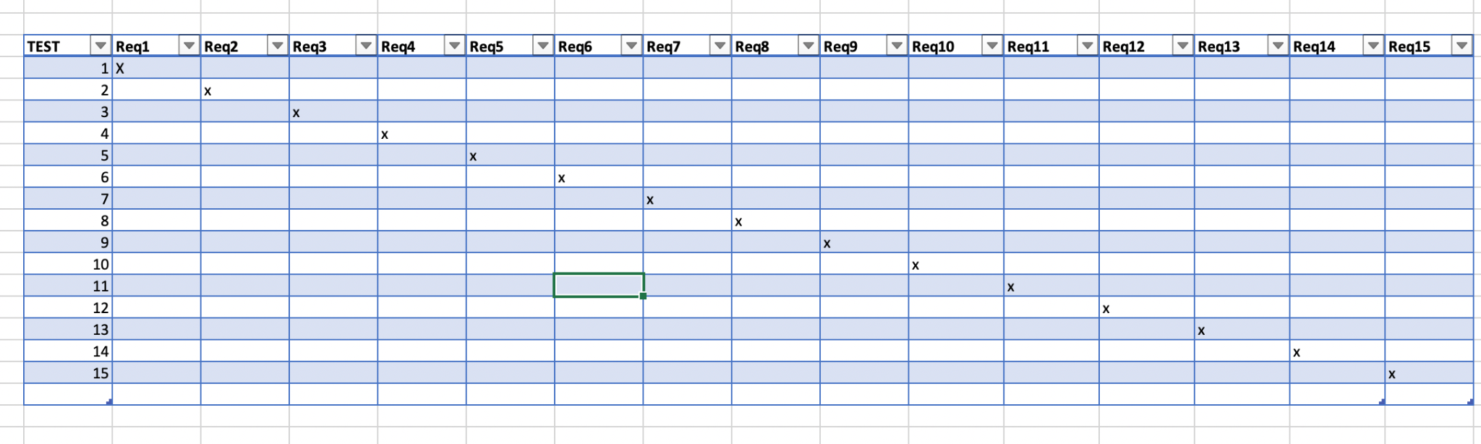

### Acceptance Test Descriptions

**ID 1 - Tutorial**

**Description:** Whenever a user creates a new account, a self-sufficient algorithm shows different elements, options and features of the application to the users.

**ID 2 - Import and parse data from multiple merchants**

**Description:** Takes input data from third party merchants and shares them with members of the group.

**ID 3 - Backup**

**Description:** Backs up account information and app settings automatically with the server. This initiates only when set up by the user previously.

**ID 4 - 10 Members per Group**

**Description:** Simple test which checks that there are no more than 10 members in a group.

**ID 5 - Images/Audio/Video Files**

**Description:** Basic test to check if the users are able to send media through the application.

**ID 6 - Minimal Storage**

**Description:** Checks during the installation if the user has at least 100MB of storage to at least install the app and get the minimal functionality.

**ID 7 - Temporary Server**

**Description:** Before sending any media, the application stores the process on a temporary server.

**ID 8 - Low Latency High Accuracy**

**Description:** The application should have low latency and high accuracy.

**ID 9 - Multiple shares**

**Description:** If a user wants to share a single video to multiple people, processing can be done only once and not for each share individually.

**ID 10 - Video Quality**

**Description:** The video quality should be set automatically for video calls.

**ID 11 - Privacy**

**Description:** Accurate tracking of the data is important for maintaining the privacy of the user.

**ID 12 - Payment Gateway**

**Description:** Bank information should be accurate, may require 2 step authentication.

**ID 13 - Backup and Recovery**

**Description:** Account backup and recovery should be carried over only on the main server.

**ID 14 -** Minimum Server Capacity

**Description:** Minimum capacity of 1 million active users are supported.

**ID 15 -** Maximum Media Capacity

**Description:** Media capacity capped at a certain limit for each kind of media.

**ID 16 -** Stability Rate

**Description:** Operate at a very high success rate.

**ID 17 -** App Crashes/Update

**Description:** No data loss in case of app crashes.

**ID 18 -** Availability

**Description:** Available all year round 99.9% of the time.

**ID 19 -** States

**Description:** Very less to no data loss in any state of the application.

**ID 20 -** Device Switching

**Description:** Works across all devices. No data loss in case of switching devices.

**ID 21 -** Short Term

**Description:** Health and financial loss.

**ID 22 -** Long Term

**Description:** Health issues.

**ID 26 - Capacity of users**

**Description:** The product should be able to handle 1 million people at a time. Though there is a possibility to reach 5 million in the first 3 years of the release.

**ID 27 - Budget fixed for 5 years**

**Description:** The product should be able to operate on the fixed budget or decided budget for at least 5 years.

**ID 28 - Admin Access**

**Description:** Additional access to group admins.

**ID 29 - Basic user access**

**Description:** user access options

**ID 30 - Account safety**

## Description: Situations for account reset/recovery

## 

## Index

Design 61, 63

Requirements 35, 51, 58

Test 64, 65